OpenVAS — Setup, Scan & Report

Task Number: 2.2 OpenVAS GVM report
Name: Hardik Kotawdekar
Intern ID: APSPL2635998
Date: 12 Jun 2026

Definition — quick overview
OpenVAS (now part of GVM) and Nessus Essentials are vulnerability scanners. They automatically probe systems and networks to find security weaknesses — unpatched software, misconfigurations, weak/default credentials, open services, and other potential attack vectors. OpenVAS/GVM is open-source and free; Nessus Essentials is free for learning/personal use.

Purpose
Use these tools to automatically detect and prioritise vulnerabilities so you can fix the most dangerous issues first and make systems harder to attack.

Setup — OpenVAS / GVM (Kali example)
- Install the package:
sudo apt install gvm
- Initialize and sync feeds (this downloads the vulnerability tests): follow the initialization steps your distro provides (e.g., gvm-setup or gvm-manage-certs where applicable).
- Start the GVM services:
sudo gvm-start
- Open the web interface (Greenbone Security Assistant) in your browser:
https://127.0.0.1:9392
- Create or use an existing user to log in.
Notes: initialization can take time while feeds download. On Kali the install/initialization commands may vary slightly depending on the package version — but the flow is the same: install → initialize/sync feeds → start services → log in.

Practice scan — Metasploitable2 (example)
Target details
- Name: Metasploitable2
- IP: 192.168.56.101 (host-only network)

Steps
- Log into GSA (Greenbone Security Assistant).
- Add the target with the IP above.
- Create a scan task and choose the target.
- Select a scan profile — for practice use Full and Fast (good balance of depth and speed).
- Start the scan.
What happens: the scanner sends probes and tests (NVTs) to the target and reports findings automatically.

What the scanner detects (examples)
- Outdated/unpatched services (e.g., old Apache or FTP versions)
- Default/weak credentials and login issues
- Open ports and misconfigurations that expose services unnecessarily
- Vulnerable web apps (DVWA, old CMS, etc.)
- Known backdoors and high-risk CVEs

Reading the vulnerability report
After the scan completes, GVM/OpenVAS produces a report you can export (PDF/HTML/XML). Key parts:
- Target IP: e.g., 192.168.56.101
- Vulnerability name: e.g., vsftpd 2.3.4 backdoor
- Severity: Critical / High / Medium / Low
- Affected service/port: e.g., FTP on port 21, HTTP on port 80
- Description: Short explanation of the issue and how it works
- Solution / Mitigation: Practical steps — patch, change config, disable service, or tighten access controls

Severity — how to prioritise
- Critical: Immediate danger — often simple to exploit and can give full compromise. Fix right away.
- High: Serious issue. Attackers could exploit under common conditions — schedule rapid remediation.
- Medium: Moderate risk — may require specific conditions or user interaction. Plan and patch.
- Low: Informational or unlikely to be exploited. Track, and fix when convenient.

Deliverable — what your OpenVAS report should show
When you export the PDF report after scanning the Metasploitable2 VM, it should clearly include:
- The target IP: 192.168.56.101
- A list of vulnerabilities discovered, each with severity (Critical → Low)
- Affected services and port numbers (so the ops team knows where to act)
- Concise descriptions and concrete remediation steps for each finding
- A summary that prioritises actions (e.g., “Patch Apache on port 80 — Critical”)
Why this matters: the report proves you scanned the target, correctly identified and classified vulnerabilities, and provided actionable mitigation steps — exactly what’s expected for Task 2 Step 3 or any hands-on assessment.

Export formats
GVM/OpenVAS supports export to PDF, HTML, and XML. For submission or audits, PDF is the most common choice.

Final summary (human, plain)
- OpenVAS and Nessus Essentials are automated vulnerability scanners used in security testing and hardening.
- Install and initialise OpenVAS/GVM, start the service, and log into the Greenbone web UI.
- Add Metasploitable2 as a target with IP 192.168.56.101, run a Full and Fast scan, and export the PDF report.
- Use the report to prioritise fixes by severity (Critical → Low) and include clear remediation steps.
- This demonstrates practical scanning skills and produces a deliverable suitable for blue-team/red-team learning or coursework.
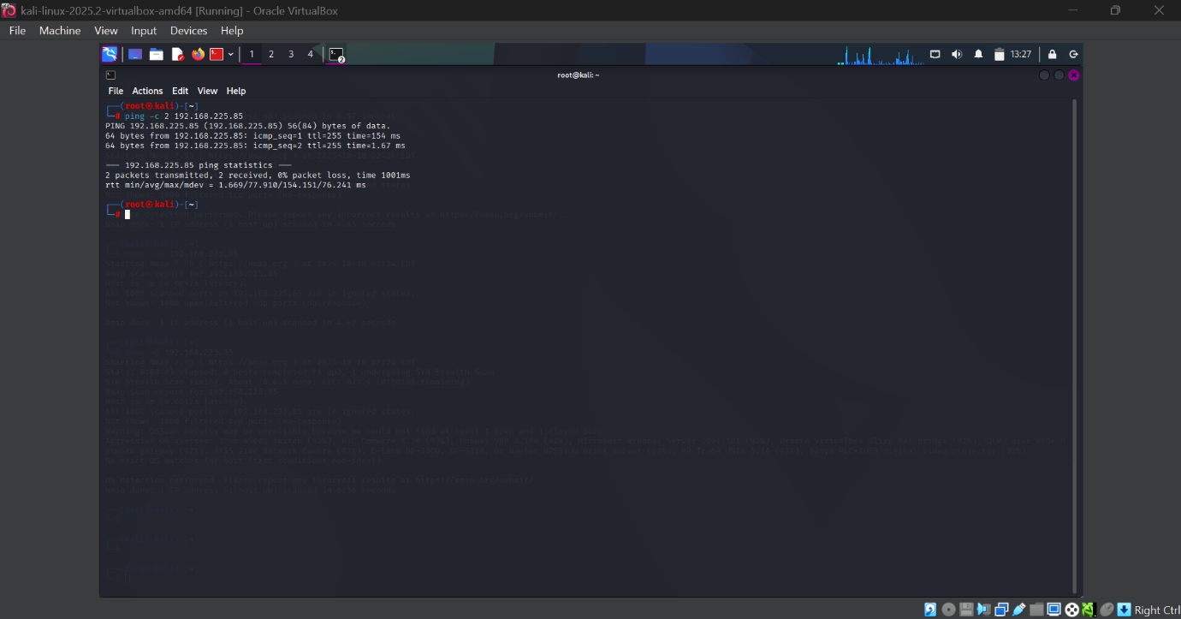
Visual Evidences
